Browser reviews :-

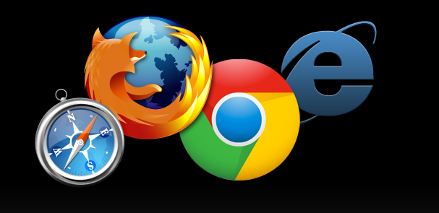

Most of the internet users want their web browsing to be faster and safer. Different browsers can render webpages differently, and there can be a large disparity in performance between the top competitors. But what according to them is secure browsing? Which Browser provides you most Secure and fast browsing? Which Browser has good ease of use?. Coming to security which has Most of the Security features? And atlast. What Makes you Happy Browsing Experience ?.Want to know Answers for all these questions. This review provides u all this Stuff u wanted to know ☺

There are Many browsers like Internet explorer , Chrome, Safari, firefox, Opera, Maxthon .etc. but among all these only some of them are really good .

Browsers are generally rated According to Security, Speed and compatibility, Ease of use.

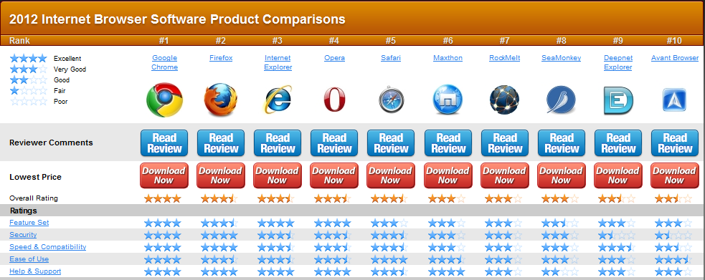

Lets take a Close at them ……

Mozilla Firefox:-

Firefox is known for its Good Interface, Addons and security features. It handles tasks nicely, and its always stable. 40% Of the Internet users prefer this browser. If you need an extension for something, the Firefox extension capabilities are powerful and easy to use. It also offers many themes. I have been using Firefox since day one and, compared to the others, it is in a class by itself -- although Opera,Chrome does come extremely close. Firefox, as well as all other browsers, can be downloaded, installed and run in conjunction with any existing browsers you have[.](http://compu-smart.hubpages.com/_www/hub/What-is-the-best-browser)This is the Best Browser one can have if he is interested in Addons, Themes, userscripts To modify the Browsers as the way he want. ☺

Overall Rating :- 8.75/10

Addon rating :- 9/10

Speed:- 8/10

Security:- 8.5/10

Ease of use :- 8.5/10

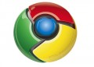

Google Chrome:-

Light weighted ultrafast, good Security features. That is Google Chrome! It is the One of the most Powerful and preferred browsers in the World .Till Date (2012) Almost 36% of the internet users Use Chrome. The Main Reason for such a huge Craze of this Browser is light weight And Easy to use. But there are bugs too!. Google Chrome had many Crash reports since 2010. it is unable to load many webpages Due to its URL Extension issues .As many as 5% of chrome users Reported About this Crashes to the Google. Since then, Google has been working to overcome these problems in the Coming releases of Chrome. But, now the Chrome is packed with Good Interface. But comparably, Firefox beats Chrome in the Security features and Webpage handling .Chrome Also offer a web store for its add-ons. Check it out for Add-ons and extensions you need. . It’s really Cool!.

Overall rating: - 8.5/10

Add-ons:- 8/10

Speed: - 9/10

Security: - 9/10

Ease of use: - 9/10

Internet Explorer:-

#### One of the oldest browsers in the internet. It is used by Most of the internet users to download other browsers...loll ☺. It competes with chrome and Firefox in terms of security. But in speed, it sucks!. 20 % of the Users uses it. For such a popular browser, it's losing its popularity every day, but it is still one of the most popular browsers. It has a new navigation bar and a better design . Its Help and Customer Support is good.

#### Overall rating:- 7.5/10

#### Speed:-6/10

#### Addons:-7/10

#### Security :- 9/10

#### Ease of use :-7/10

#### C:\Users\Vamshi\Desktop\tech\3941345_f120.jpg

#### Apple Safari:-

#### One of the most innovative Browser from Apple.inc. It Has been used in all apple devices. It has a rich font and a classy interface. One can Browse web pages full screen, save articles to Reading List, and interact with the web as never have before. It has a Special reading tab designed for the people who read articles a lot. It takes Advantage of Apple Os .However it is also released in PC, it doesn’t Have much Users in PC. When Coming to Speed,its good. And security features takes some improvement. Very few addons in safari when compared to chrome,firefox. Ease of access is Pretty decent.

Overall rating :- 7/10

Securty :- 8/10

Ease of use :- 8/10

Addons:- 6/10

Speed:- 8/10



Opera:-

It is most stylish and is a multimodal browser, meaning it contains features that enable multiple modes of interfacing with the browser. more than 200 million users worldwide use opera. Opera’s multimodal interaction is just one of its many cutting-edge features, and the browser also boasts competitive launch and page-load times and comprehensive user support. The latest version of Opera delivers a refined user interface, one that boasts a clean, featherweight design that emphasizes the content and not the browser. Opera’s compatibility issues are likely to be the deciding factor for many prospective users, but more and more websites become compatible with the browser each day. it manages to stay on par with the competition with its robust feature set, advanced security protocols and rapid speeds.

Overall raring :- 8/10

Speed:- 8/10

Security:- 7/10

Ease of use ;- 8/10

Addons :- 6/10